How it works: input into the import_wd the wds to be created on the left as well as the templates on the right, all available templates are also shown in the import wd excel
Close the file and run import script.py, it will ask for a unique batch code that you can use to identify the file when uploading to oracle.
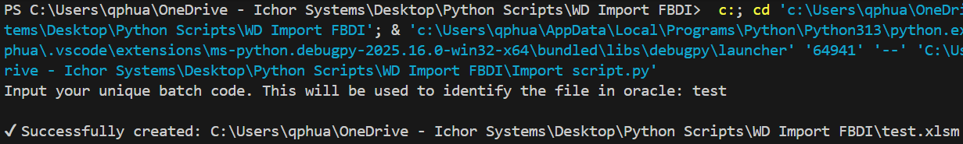
A file containing all relevant information will appear, and you can check the details of everything first before importing. The ones to take note are:
Work Definition Headers: Check if you want the item to be serial tracked or not, this will feed into work definition operations and may cause errors if the item is a non serial FG
Work Definition Operations: This is where all the individual cards are created with the correct sequence and operation number. Usually, you would look out for which are count point/automatic transact, and which needs serializing
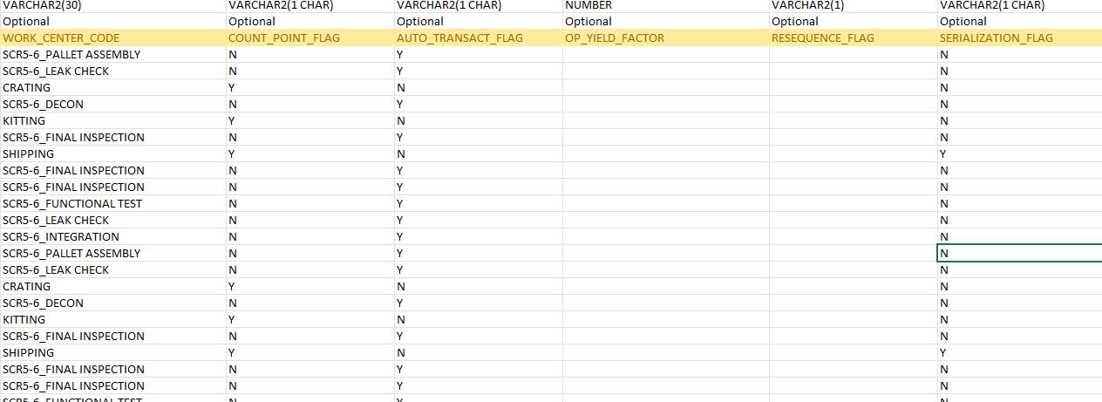
Operation items – Standard: This is the bom list that will be auto added to the basket of each wd.
Operation Resources: This is the largest source of error that includes
- Incorrectly labelling a resource as create or update
- Incorrect sequence
- Missing or extra sequences from WD operations
- Etc

After checking, use the macro genCSV to generate a zip file that can be imported to oracle
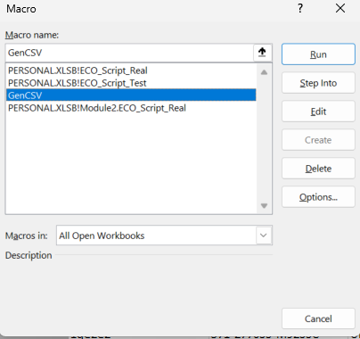
Navigate to scheduled processes in oracle and create new process: Load Interface file for importing
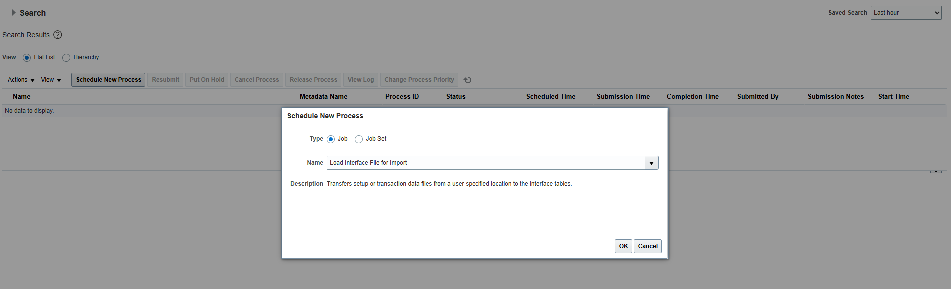

Select import work definitions and upload the zip file you created
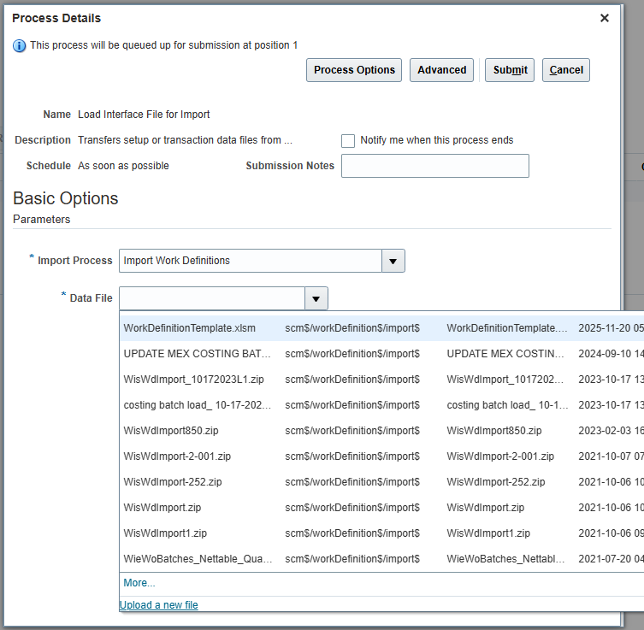

Monitor the process for errors, if none, then schedule a new process to Import Work Definitions
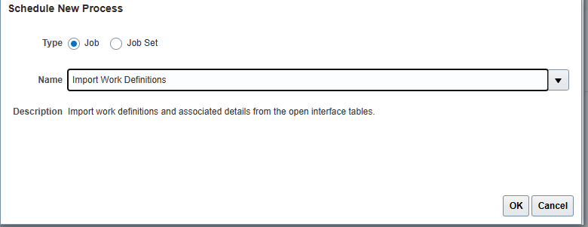
Select the batch file with your chosen name and submit.
All the WDs will be automatically created unless there is an error.

